AWS ATHENA How To Tutorial

Creating Databases and Tables

Creating S3 Bucket with managing settings Steps

Creation date: December 2,2023

Created by: Ernest Garcia

**1. Login to the console and click on services then search up S3**

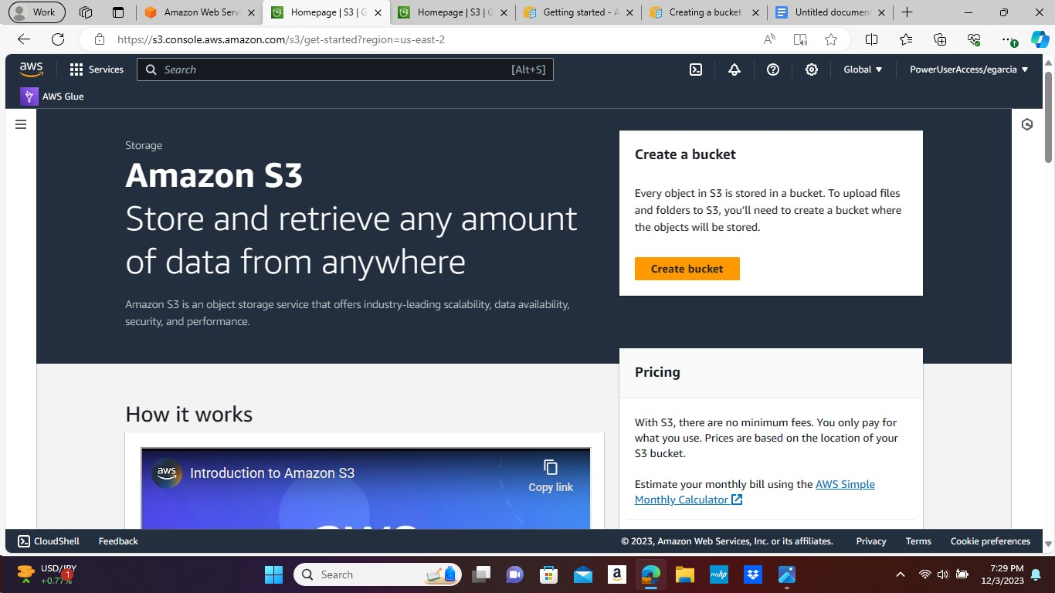

**2. On the S3 page click on the orange box Create Bucket on the right corner.**

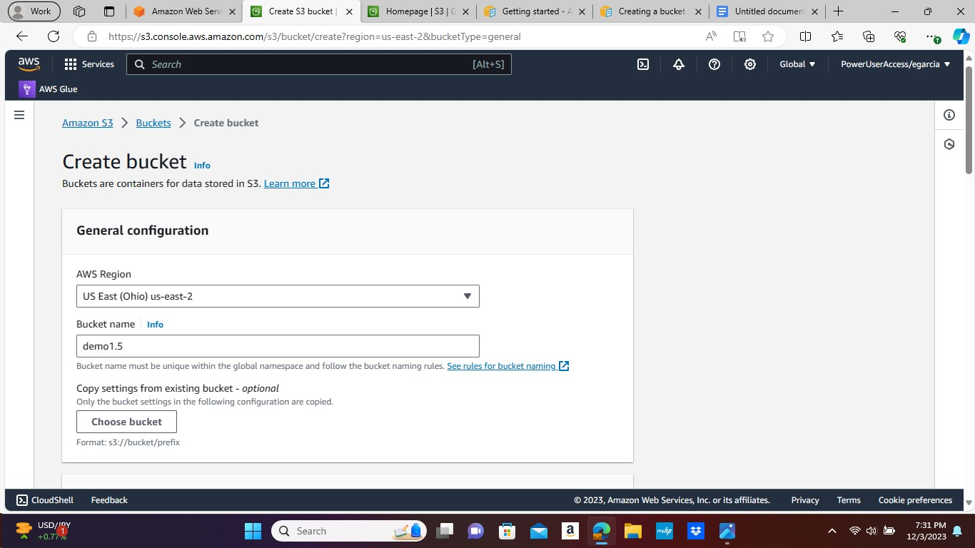

**3. Create Bucket and General configuration the AWS Region is US East (Ohio) leave alone and name Bucket demo1.5**

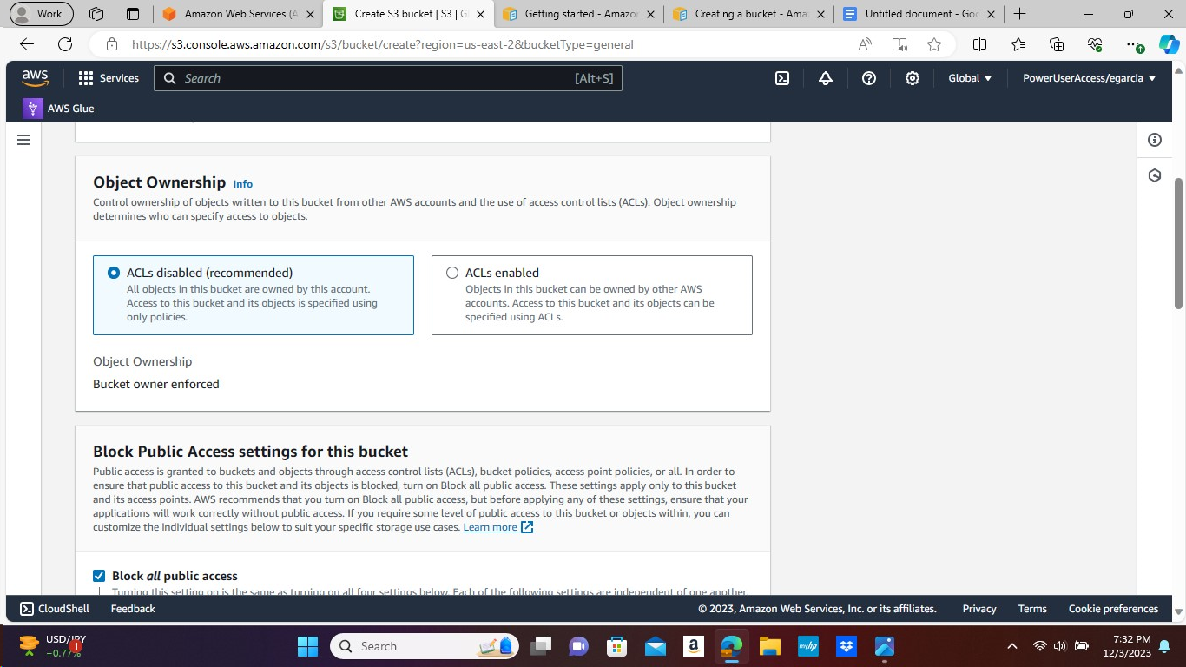

**4. On Object Ownership leave ACLs disabled option alone and proceed scrolling down.**

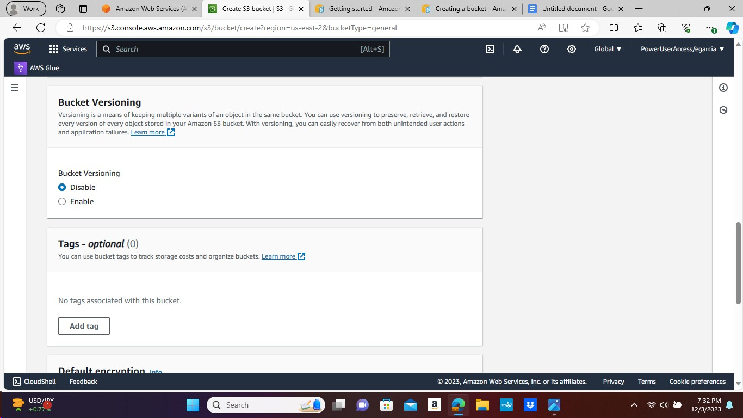

**5. On Bucket Versioning leave it Disabled and keep scrolling down.**

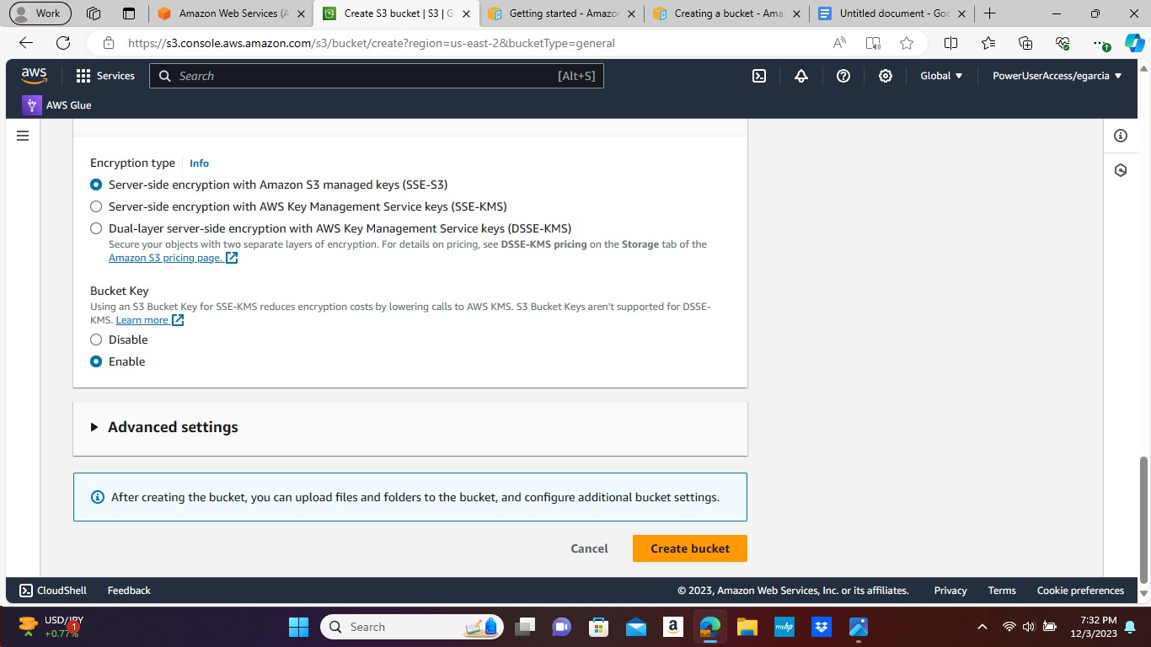

**6. After scrolling all the way down you will see the orange box that says Create Bucket on the bottom right corner and click to proceed.**

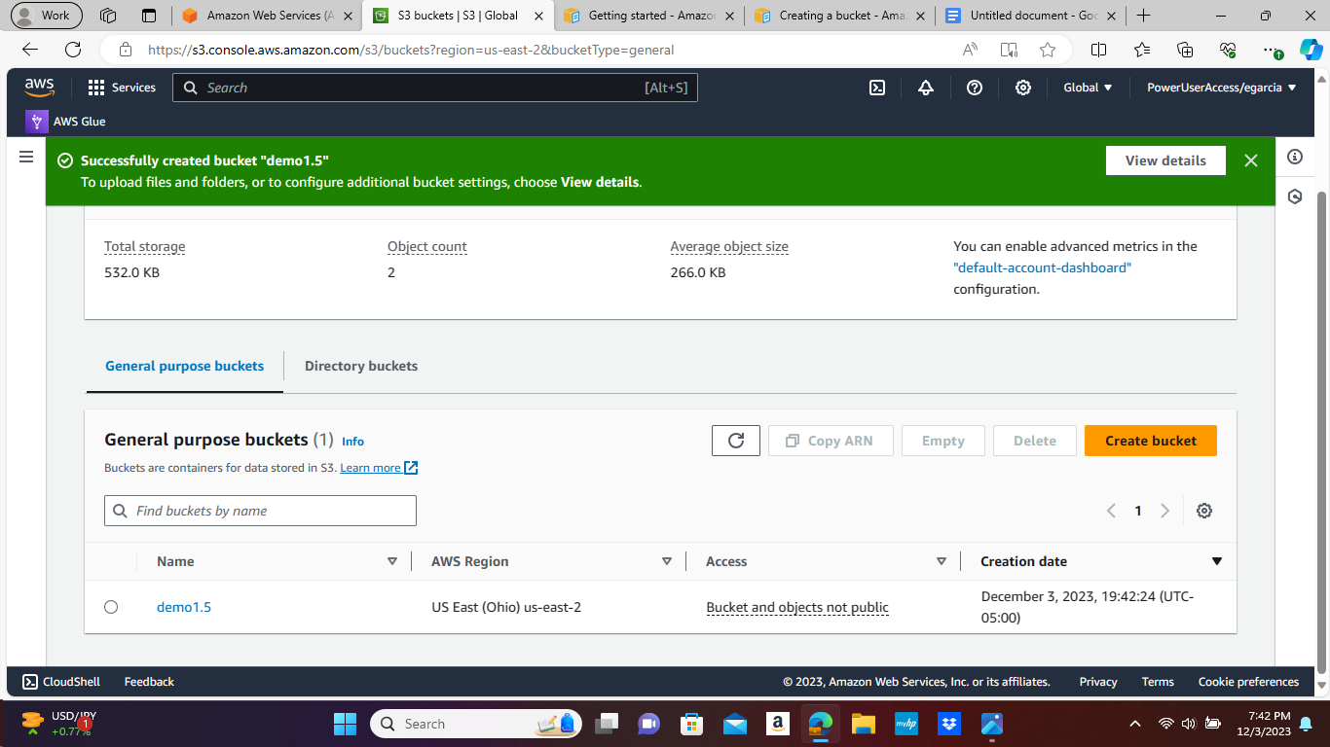

**7. The Green tab on the top is showing it Successfully created bucket demo1.5**

**The General purpose buckets show demo1.5 with the rest AWS Region, Access, and Creation Date.**

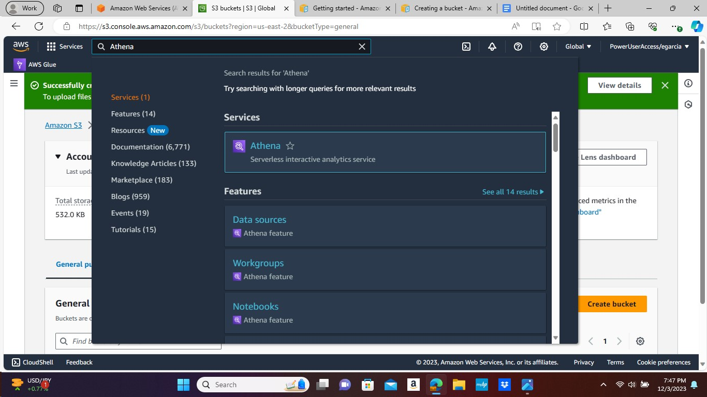

**8. Services tab search Athena and click on it.**

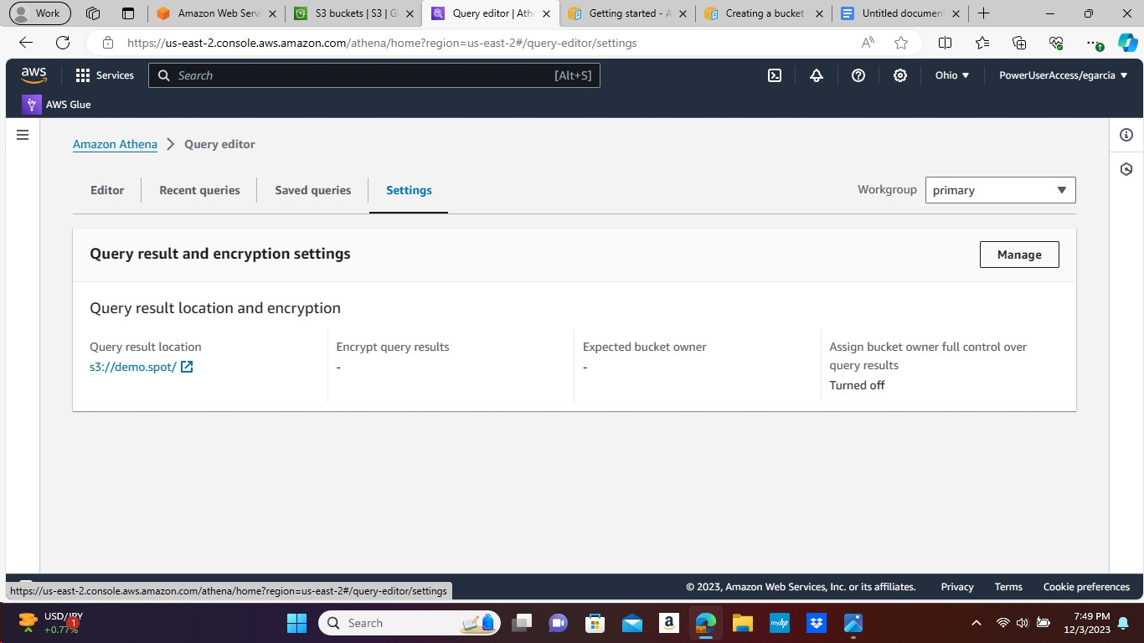

**9. On Amazon Athena Query Editor under is Settings and click on Manage button on the right corner.**

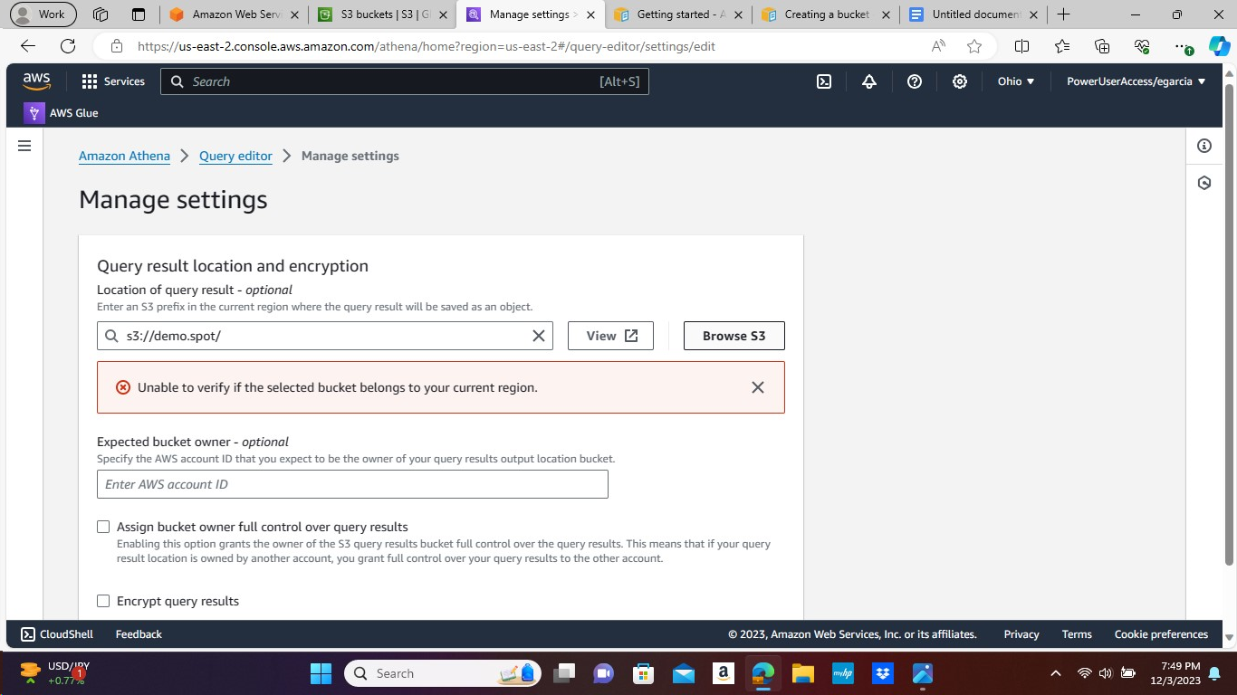

**10. Next, the Manage Settings page will show up and then click on the Browse S3 box.**

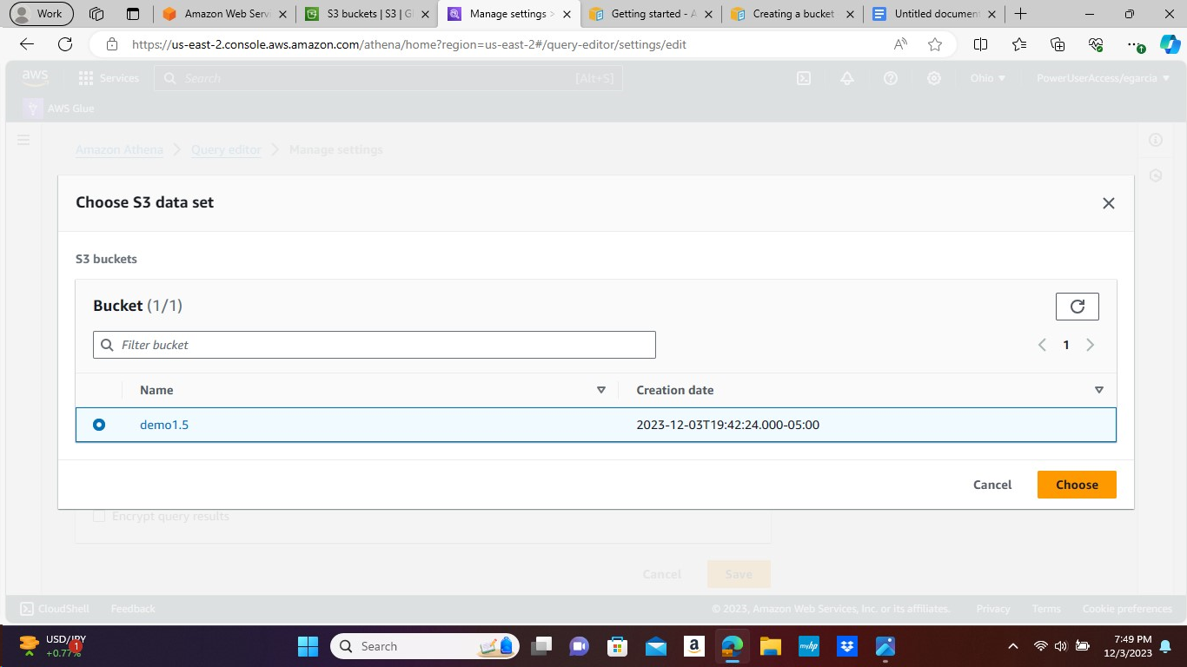

**11. After, the Choose S3 Data set shows up under S3 Buckets and Bucket tab choose the demo1.5 and then click on the Choose orange box on the right corner to proceed.**

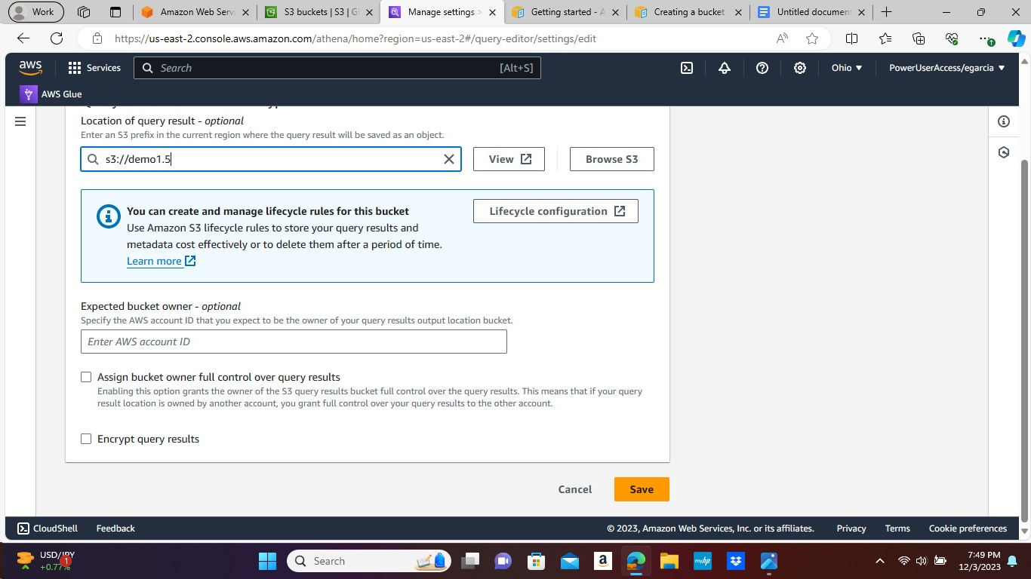

**12. Then back on the page click on the orange Save button on the bottom right.**

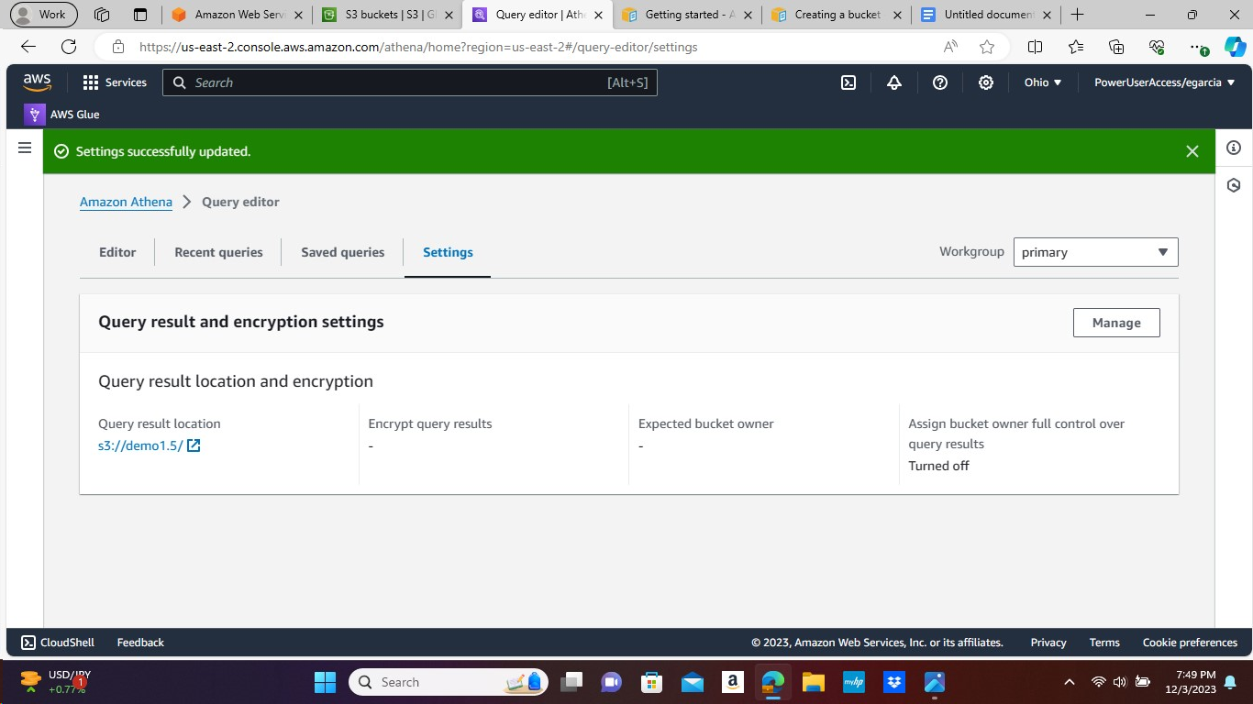

**13. The settings successfully updated and the Query result location is under demo1.5.**

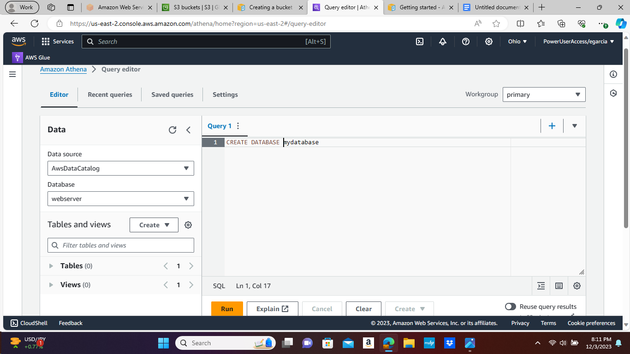

**14. On the Query Editor page to create a database type in mydatabase and enter the following CREATE DATABASE and then click on Run.**

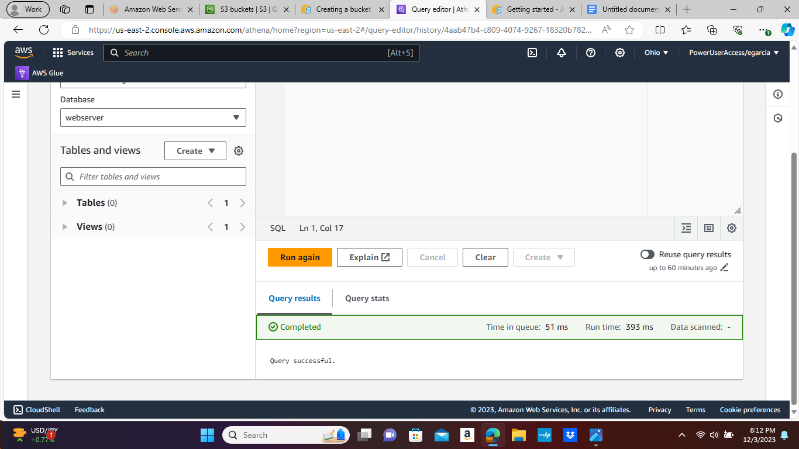

**15. It shows Completed in green and Query successful.**

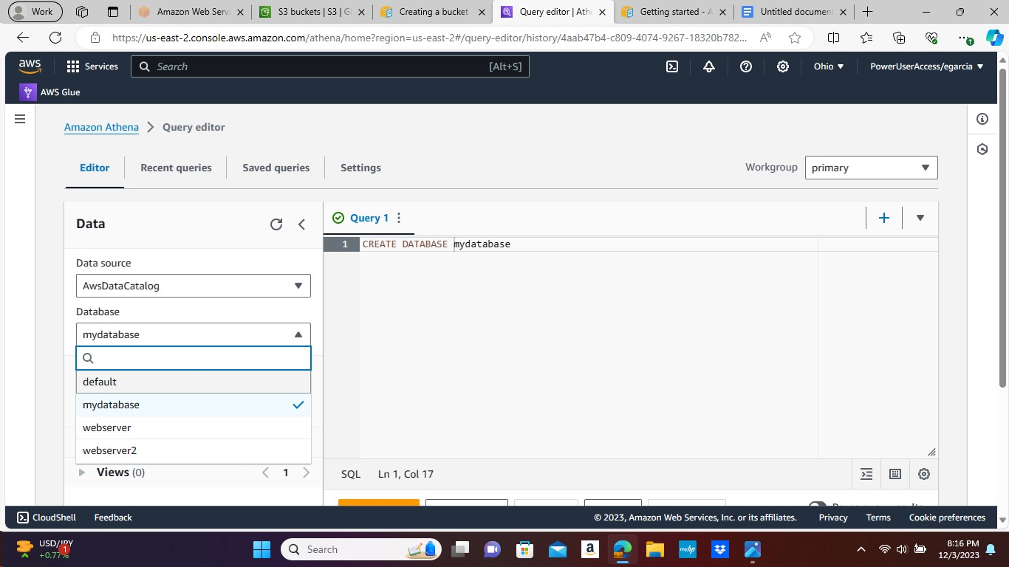

**16. From the Database list scroll down and click on mydatabase.**

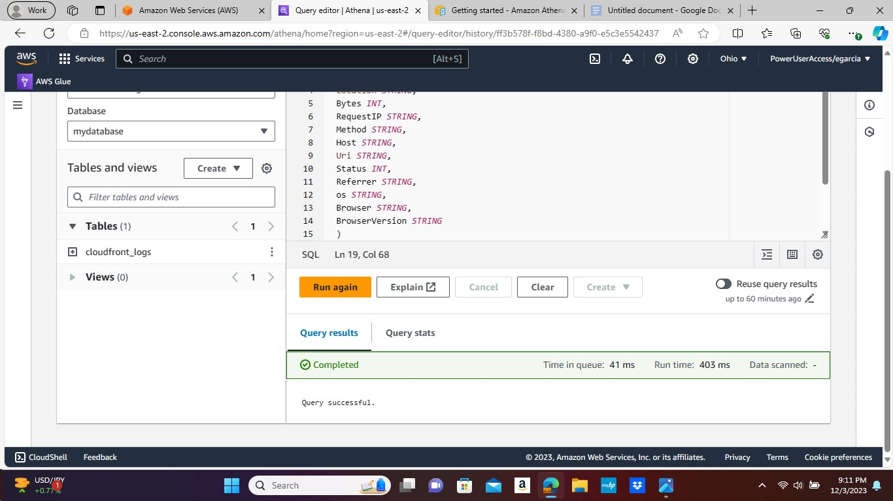

**17. Then from there we get the Cloud front logs showing on the Tables. Completed in Green and Query Successful shows.**